**TIC-TAC-TOE GAME**

### A Project Work

*Submitted in the partial fulfillment for the award of the degree of*

# BACHELOR OF ENGINEERING

### IN

### COMPUTER SCIENCE SPECIALISATION

### CLOUD COMPUTING

### Submitted by:

### VARINI MALHOTRA

### UID: 20BCS4235

### Under the Supervision of:

### MS. DEEPANSHU GARG



# DEPARTMENT OF COMPUTER SCIENCE AND ENGINEERING APEX INSTITUE OF TECHNOLOGY

### CHANDIGARH UNIVERSITY, GHARUAN, MOHALI - 140413,

**PUNJAB**

**JULY,2021**

**TIC-TAC-TOE GAME**

### A Project Work

*Submitted in the partial fulfillment for the award of the degree of*

# BACHELOR OF ENGINEERING

### IN

### COMPUTER SCIENCE SPECIALISATION

### CLOUD COMPUTING

### Submitted by:

### VARINI MALHOTRA

### UID: 20BCS4235

### Under the Supervision of:

### MS. DEEPANSHU GARG



# DEPARTMENT OF COMPUTER SCIENCE AND ENGINEERING APEX INSTITUE OF TECHNOLOGY

### CHANDIGARH UNIVERSITY, GHARUAN, MOHALI - 140413,

**PUNJAB**

**JULY,2021**

**DECLARATION**

I, **‘Varini Malhotra’**, student of **‘Bachelor of Engineering in Computer science’**, **session: 2020** , Department of Computer Science and Engineering, Apex Institute of Technology, Chandigarh University, Punjab, hereby declare that the work presented in this Project Work entitled ‘**Tic-Tac-Toe Game’** is the outcome of our own bona fide work and is correct to the best of our knowledge and this work has been undertaken taking care of Engineering Ethics. It contains no material previously published or written by another person nor material which has been accepted for the award of any other degree or diploma of the university or other institute of higher learning, except where due acknowledgment has been made in the text.

**(Varini Malhotra)**

**Candidate UID: 20BCS423**

#### Date: 27th July,2021

**Place: Chandigarh University**

**ACKNOWLEDGEMENT**

Project is like a bridge between theoretical and practical working. With this

willing I joined this particular project. First of all,I would like to thank the

supreme power the Almighty God who always guided me to work on the

right path of life. Without his grace this project could not become a reality.

I am feeling oblige in taking the opportunity to express my gratitude to

Ms. Deepanshu Garg (Ass.t Professor) who have been the great inspiration

and who have provided sufficient background knowledge and understanding

of C++ subject throughout the Institutional Training.

I am also indebted to my family and friends for their invaluable support and

advise which helped me to do this project within the given time frame.

**Name: Varini Malhotra**

**UID: 20BCS4235**

**ABSTRACT**

This report is all about the Tic-Tac-Toe Game. Tic-tac-toe,

(noughts and crosses, or X’s and O’s) is a paper-and-pencil

game for two players, X and O, who take turns marking the

spaces in a 3×3 grid. The player who succeeds in placing

three of their marks in a diagonal, horizontal, or vertical row

is the winner. Most of us have played this game in our school

days, I have made a C++ program on it. This game is very

popular and is fairly simple by itself. This game uses board

to control players. In each turn players enter a number and

choose a move.

Simplify programming assumes that player one always moves

first position and uses X’s. player two moves second position

and uses O’s.

This game project has two modes:

1. Player vs Player
2. Computer vs Human

This report is an introduction to the Tic Tac Toe game in

C programming

This report is an introduction to the Tic Tac Toe game in

C programmin

**List of Figures**

1. No table of figures entries found.

# Table of Contents

|  |  |  |
| --- | --- | --- |
|  | Title Page  Declaration of the Student Abstract Acknowledgement  List of Figures | i |
| ii |
| iii |
| iv |
| v |
| **1.** | **INTRODUCTION\*** | **1** |
|  | * 1. Problem Definition   2. Project Overview/Specifications* (page-1 and 3)   3. Hardware Specification   4. Software Specification 1.3.1   1.3.2  … | 1  2  3  4  4 |
| 1. **LITERATURE SURVEY**    1. Existing System    2. Proposed System    3. Feasibility Study* (page-4) 2. **PROBLEM FORMULATION** | | **5** |
| 5  6  7 |
| 9  16  18  19  22 |
| 1. **OBJECTIVES** 2. **METHODOLOGY** 3. **CONCLUSIONS AND DISCUSSION** 4. **REFERENCES** | |

# INTRODUCTION

# Tic-tac-toe also known as noughts and crosses is a paper and pencil game for two players,

# who take turns marking the spaces in a 3 x 3 grid traditionally. The player who succeeds

# in placing three of their marks in a horizontal, vertical or diagonal row wins the game.

# It is a zero-sum of perfect information game. This means that it is deterministic with fully

# observable environments in which two agents act alternately and always equal and opposite.

# It is a solved game with a forced draw assuming best play from both players.

# 

**Tic-Tac-Toe Game**

# 1.1 Tic-Tac-Toe Game Rules:

# 1) The board will be displayed on a grid that’s 3 squares by 3 squares.

# 2) The first player’s symbol will be X, and the second player’s symbol will be O.

# 3) The turn will change after every successful mark.

# 4) To win the game, the symbol of the player should be consecutive horizontally,

# vertically or diagonally.

# 5) If all the 9 positions are marked and there is no winner, then the game will be drawn.

# 

**1.2 Modes of Tic-Tac-Toe Game:**

1. **Player vs Computer mode**
2. **Player vs Player mode**

**1.2.1 Player vs Computer mode**

In player vs computer mode, the game will ask the user to enter name

and after that the choice between (1-9) where he wants to enter the

mark (X or O).

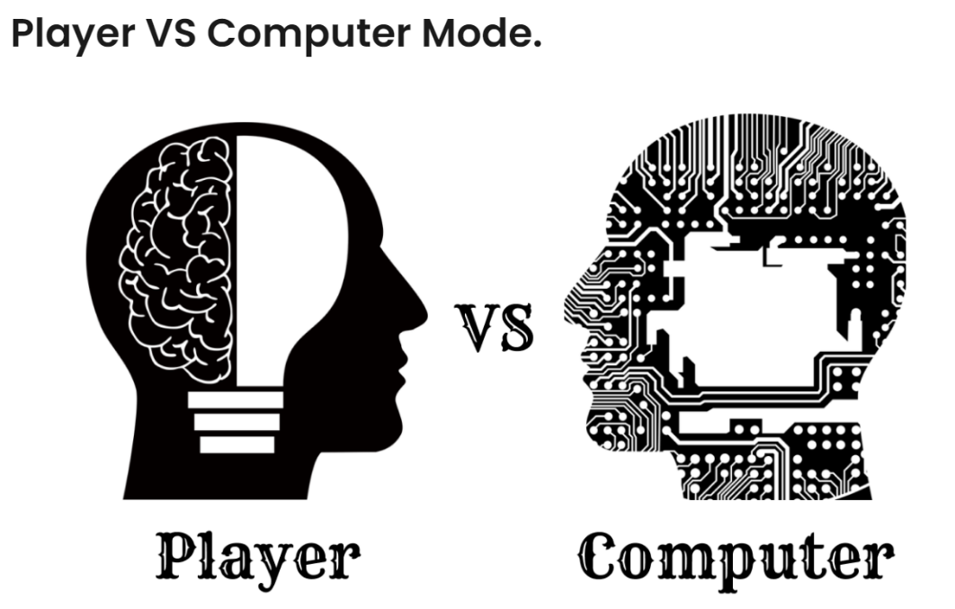

**Player vs computer**

The game will verify the user choice by checking two conditions:

1. The user choice must be in range (1-9).
2. The user’s selected position must be empty.

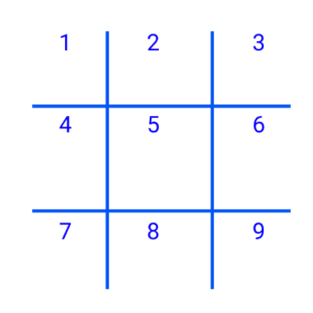

**range of user**

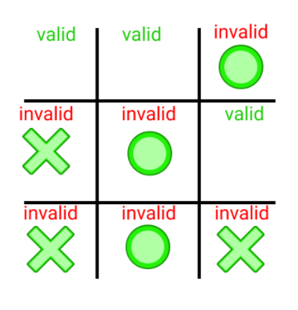

**Valid and invalid choice**

**1.2.2 Player vs Player mode**

In Player VS Player Mode, the game will ask the user to enter the name

of the first Player and then the name of the second Player. Then the

game will start and it will first get the choice from the first user. The user

will select the number between 1-9 which represents the position of the

game board. The game will verify the user by checking two conditions.

The game will change the **turn** after successful position mark.

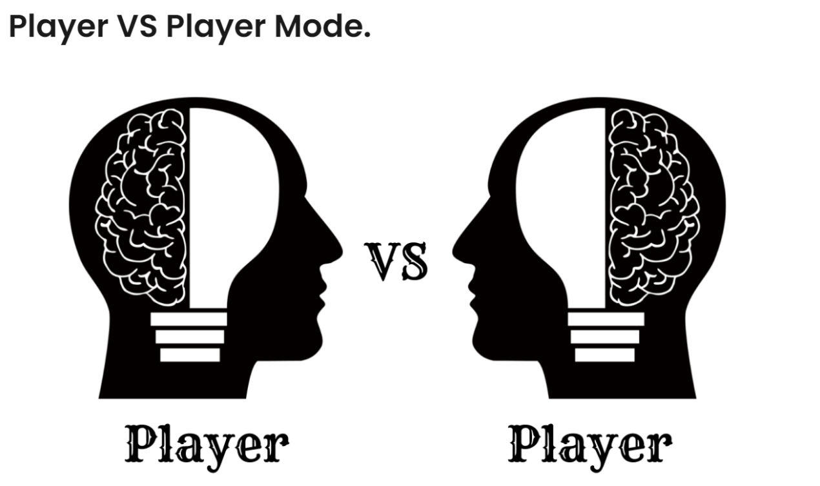

**1.3 CHANGE TURN**

When first player successfully marks any position, then the **turn** will be shifted to

the second player and vice versa.

* 1. **Tic-Tac-Toe Game Rules to Determine the Result:**

1. If any Player’s symbol appears consecutive in any row. Then the player with the symbol will

be the winner.

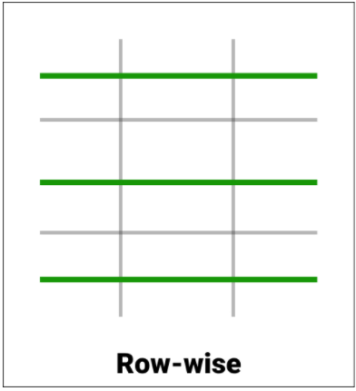

1. If any Player’s symbol appears consecutive in any column. Then the player with the symbol

will be the winner.

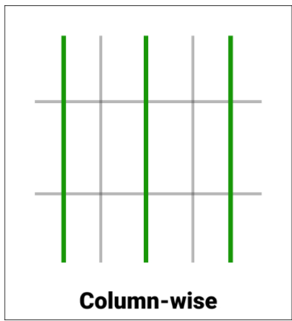

1. If any Player’s symbol appears consecutive in any diagonal. Then the player with the symbol will

be the winner.

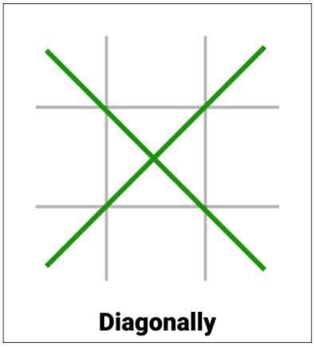

1. If all the 9 positions are marked and none of the above condition is satisfied then the game will be drawn.

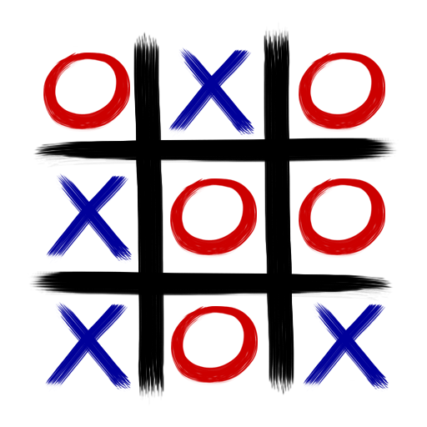

1. Hence there are only three possible results – a player wins, his opponent (human or computer) wins or it’s a tie.

# APPLICATION

1. Because of the simplicity of tic-tac-toe, it is often used as a pedagogical tool for teaching the concepts of good sportsmanship.
2. On Minute to Win It, the game Ping Tac Toe has one contestant playing the game with nine water- filled glasses and white and orange ping-pong balls, trying to get three in a row of either color. They must alternate colors after each successful landing and must be careful not to block themselves.

**2.1 LIMITATIONS**

**i**) This game can’t be played by one or more than 2 players.

ii) GUI is not so attractive.

1. It doesn’t contain levels.

**3 PLATFORM USED**

* 1. **Software Used:**

1. Code Blocks
   1. **Hardware Used:**
2. HP 250 G8 Notebook
3. 8GB DDR4-2666 SDRAM
4. Windows 10 Home Single Language 64 – HP recommends Windows 10 Pro for business
5. I 3 Processor
6. **Methodology**

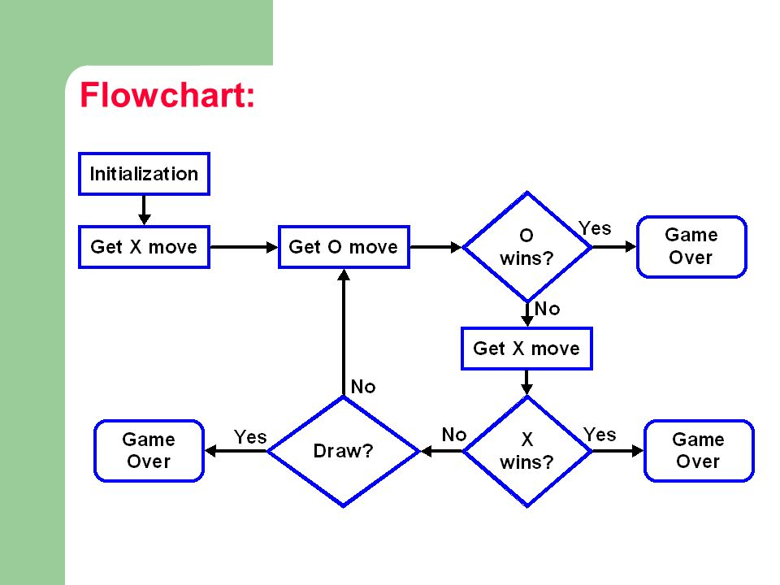

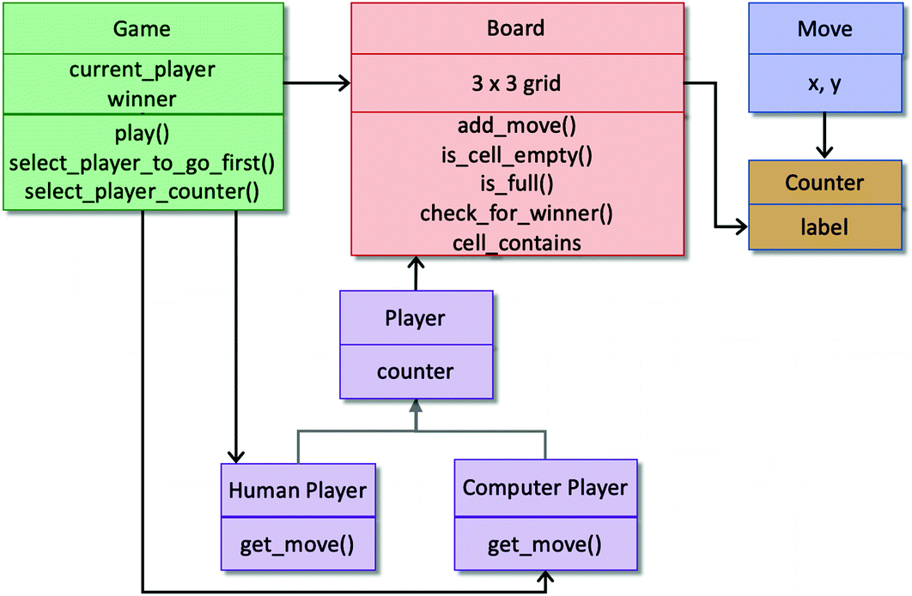

1. **Screenshot of project**

Mode -1 (Human vs Computer)

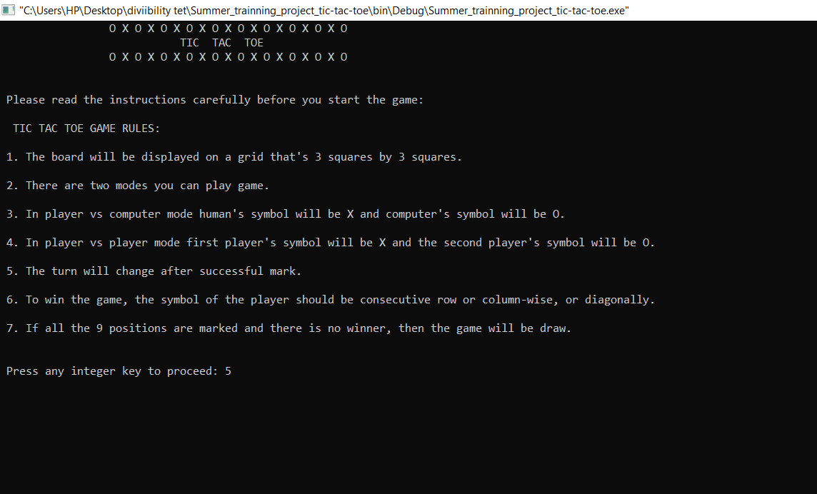

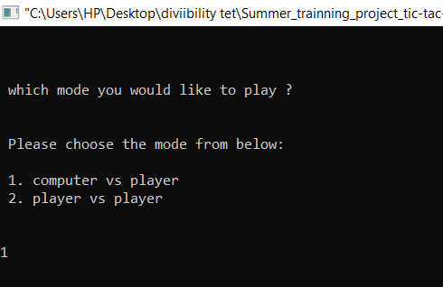

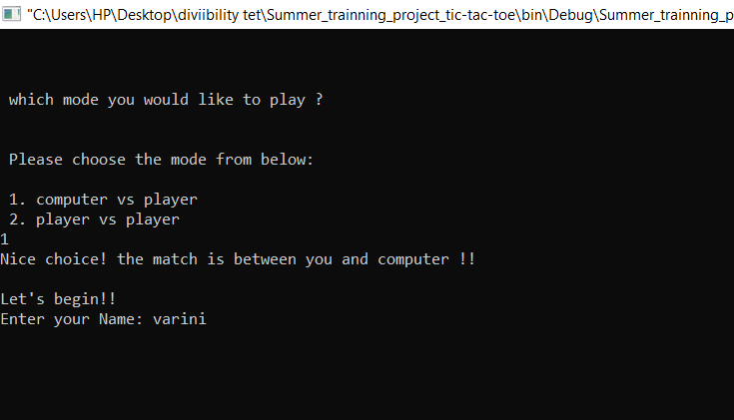

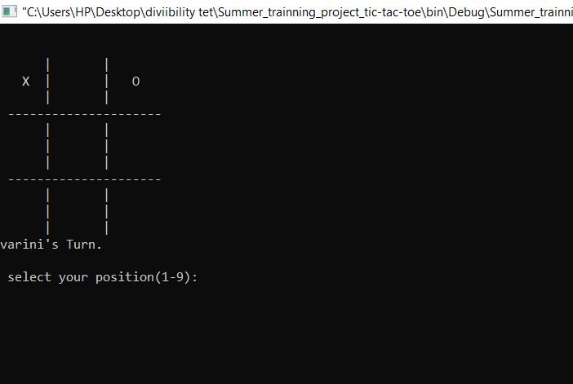

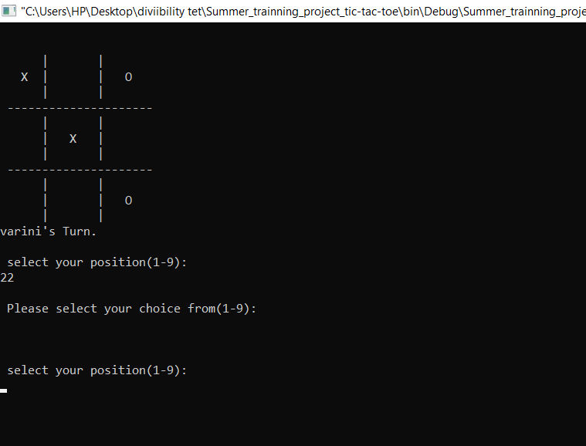

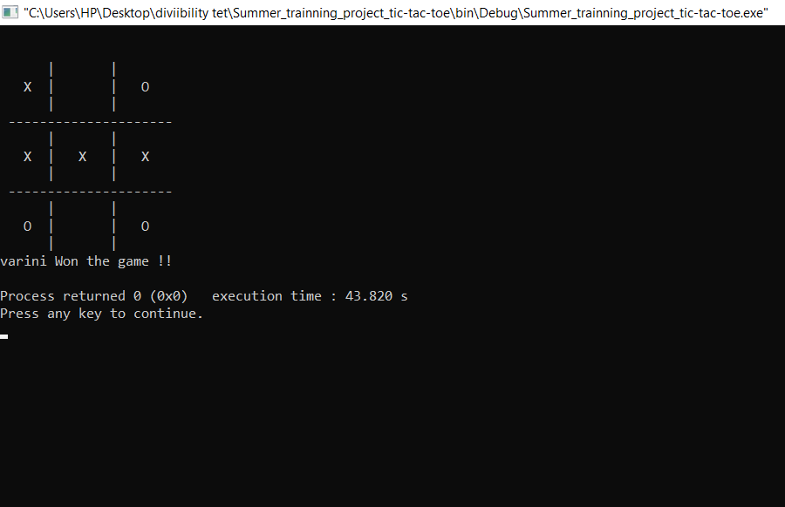

MODE-2 (Player vs Player)

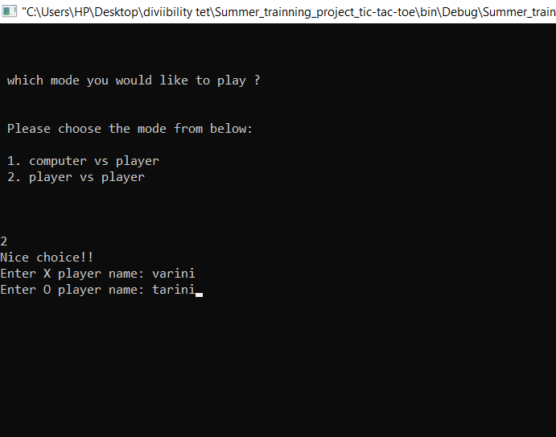

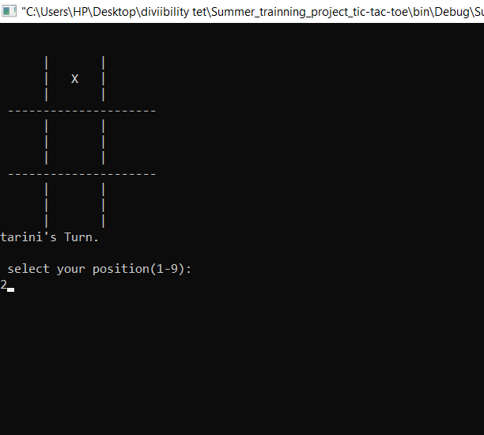

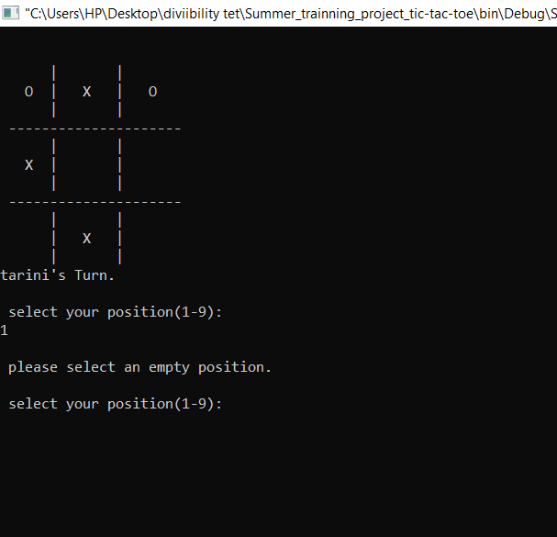

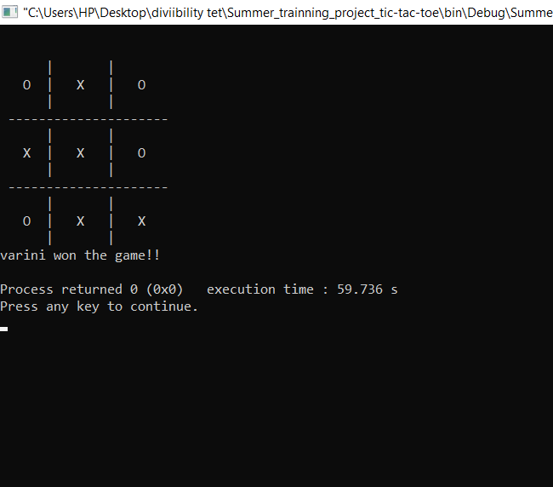

# ESEARCH OBJECTIVES

The proposed research is aimed to carry out work leading to the development of an approach for vulnerable code clone detection.

The proposed aim will be achieved by dividing the work into following objectives:

* 1. To understand and explore various types of software vulnerabilities existing in open source software.
  2. To study and analyze various clone detection techniques that are suitable for vulnerable code clone discovery.
  3. To design and develop the technique for vulnerable code clone detection.
  4. To verify and validate the proposed system.
  5. To understand the understand the concepts of C++ which were taught in the Institutional Training.
  6. To create a successful game which could be imported to as many OS as possible an also to introduce us to logic building, game sense and many more.

1. **RESULTS AND DISCUSSION**

In the conclusion of this project, I would like to say that C++ is a fun and easy programming language and while creating a project like this, it has not just been a good experience but it also helped in the development of my creativity and logical thinking. I would be more than happy to work on other projects in C++ because it’s just amazing to work with C++. The program is working and I hope, it’s also bug-free.

All the main objectives and all criteria are fulfilled and completed by me.

**6.1 Further Enhancement**

1. Work on GUI of the game and make it more attractive.
2. Implementation of Minmax Algorithm.
3. More number of winning strategies.
4. **SOURCE CODE LINK**

[**https://github.com/oreobyte2102/Tic-Tac-Toe-Project**](https://github.com/oreobyte2102/Tic-Tac-Toe-Project)

# REFERENCES

1. <https://www.geeksforgeeks.org/implementation-of-tic-tac-toe-game/>
2. <https://fahad-cprogramming.blogspot.com/2019/12/tic-tac-toe-game-c-source-code.html?m=1>
3. <https://www.youtube.com/watch?v=trKjYdBASyQ&t=1084s>
4. <https://www.youtube.com/watch?v=gktZsX9Z8Kw>
5. <https://en.wikipedia.org/wiki/Tic-tac-toe>